Request for funding of Open Access publication

version 16th January 2023

The Open Access fund of the Library Committee will only take applications into consideration when you have no other funding available and will fund only applications for publications in fully open access journals or books. Conference papers (or proceedings) and book chapters in hybrid form will be considered. So, first you have to determine if you can apply to the fund.  
Contact the OU library committee member in your faculty (or knowledge domain) if you have questions. If you are eligible for funding, you will send your request form to the secretary of the Library Committee **and your OU library committee member in cc** (see the end of this application form).

# Step 1: Read up on the OU policy on open access publication

First, read the information in MijnOU regarding OU policy on open access and the OU guidelines on open access publishing via [MijnOU – Thema’s – Onderzoek – Open access](https://mijn.ou.nl/group/mdw/-/onderzoek-open-access)[1]. Our public OU website provides generic information about our policy and research support: [Onderzoek – Onderzoeksondersteuning – Open access publiceren](https://www.ou.nl/en/open-access-publiceren), and [Over ons – Open science – Open access](https://www.ou.nl/en/open-access).

**1. Confirm that you are familiar with the open access policy.**

Yes

# Step 2: Check if you already have funding

Check if you already have funding for open access publishing. Nearly all project applications with national and international funding agencies will allow you to book the costs of open access publication on the project. Or maybe you have other, non-project related means to finance your publication.

**2. Do you have project funding (such as NRO/ NWO/ Horizon/ ERC /other projects) or internal funding available to cover APC?**

Yes

No

If you have internal or external funding, you can not apply to our fund. You can stop here.

# Step 3: Check if costs are covered by the publisher deal

This step only applies when you want to publish a journal article. When you are submitting an application for a conference paper/proceedings/book/book chapter you can skip this step and continue with step 4.

Please confirm that your application is for a conference paper/proceedings/book/book chapter.

Check the [open access journal browser](http://library.wur.nl/WebQuery/jbrowser/find?q=*&wq_flt=consortium&wq_val=OU) to look up if the journal of choice is covered by the deal, meaning that OU researchers are entitled to discount (often 100%) on the APC. Below, we give some examples to indicate what you should look for. Follow the hyperlinks for more information on the publisher deal or visit the [Open access](https://www.openaccess.nl/) website. Here you will also find information about the workflow the publisher applies and how the publisher determines if you are eligible. However, be aware that there can be a limit to the number of open access publications allowed under the publisher deal. Please note that the Library Committee has no more information about the publisher deal than is available on the website. Academic Affairs handles these publisher deals. Ask our Library Committee secretariat whom to contact for questions.

An example of a fully open access journal not covered by the publisher deal is [Health Psychology Bulletin](https://library.wur.nl/WebQuery/wurbrowser/78036).

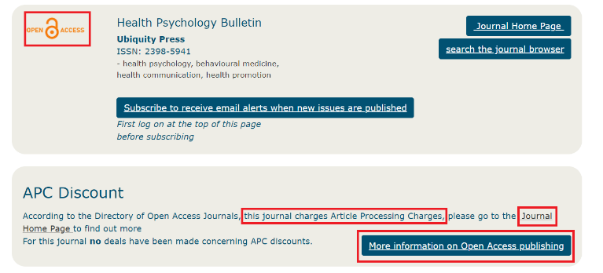

Many of the hybrid or transformative journals that offer authors the option to publish open access are covered by the publisher deal. For example, [Discourse Processes](https://library.wur.nl/WebQuery/jbrowser/6201#deal).

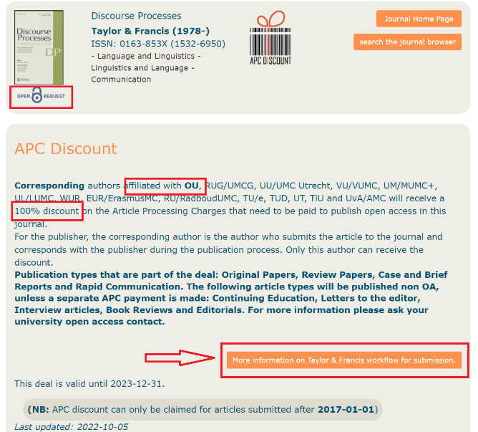

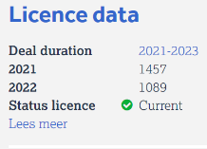 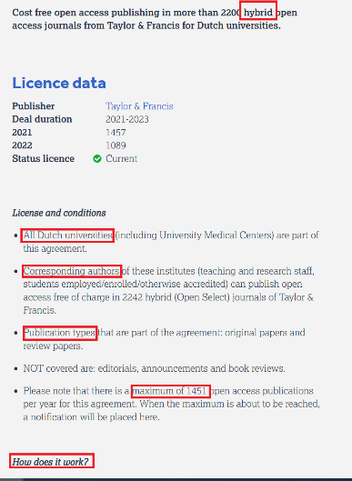

**3. Please indicate what information the open access journal browser provides for the journal of your choice.**

Give the URL of the open access journal browser for your journal:

Give the URL with the information about the publisher deal:

**4. Confirm that the journal is fully open access**

Yes

No

If the journal of choice is not fully open access, you can not apply to our fund. You can stop here. Maybe you can make use of the publisher deal.

**5. Indicate if APC (article processing cost) is covered by the publisher deal**

Yes

No

If APC is covered by the publisher deal you can not apply to our fund. You can stop here.

You have to find other funding or consider choosing another journal.

# Step 4: Check if the publisher is reliable and trustworthy

Unfortunately, not all open access publishers are reliable and trustworthy and some are known as “predatory”. You can use the [Think Check Submit](https://thinkcheckattend.org/) procedure or use the information on the [Open Access website to determine the quality of the publisher](https://www.openaccess.nl/nl/wat-is-open-access/kwaliteit) and decide if the publisher is reliable. If you want to know more about predatory publishing, you can consult some of the following websites:

* [Beall's List of Potential Predatory Journals and Publishers](https://beallslist.net/)
* [List of scholarly publishing stings](https://en.wikipedia.org/wiki/List_of_scholarly_publishing_stings)
* [Flaky Academic Journals](https://flakyj.blogspot.com/)
* [Some journals say they are indexed in DOAJ but they are not](https://blog.doaj.org/2014/08/28/some-journals-say-they-are-in-doaj-when-they-are-not/)

**6. Indicate that you checked reliability of the publisher**

Yes

No

If the publisher is not reliable, known as predatory, or reliability can not be determined you can stop here.

If you consider the publisher to be reliable, you may proceed. However, the fund still can decline your request when we deem the publisher as (potentially) predatory.

# Step 5: Check if you are eligible for the Open Access Fund

You now can check if you are eligible for an application to our open access fund.

Before filling in this request form, please read carefully the document ‘Het Open Access fonds: een initiatief van de OU Bibliotheekcommissie (versie 16 januari 2023)’ or ‘The Open Access Fund: an initiative from the OU Library Committee (version 16th January 2023)’, in particular regarding the conditions for funding.

A summary of the main conditions is given below.

* To give as many authors a chance to publish, the first author can apply for funding once every 6 months.
* An author can participate in a maximum of three applications per year, as first author (applicant) or co-author.
* There will be a limit to the budget that can be requested. A different limit is applied to APC and BPC.   
  For journal publications and conference papers/proceedings, the maximum amount for APC that **can be requested is € 2.500,- including VAT. Applications for APC exceeding this limit will not be taken into consideration**. The OA fund will not pay any invoice for an amount higher than €2,500,- including VAT even when the faculty would pay the remainder above the limit.   
  For books (book chapters) and monographs, the maximum for BPC is €4.000,- including VAT. If the application for BPC exceeds this sum, it will only be considered by the fund if the faculty covers the remainder above the limit. In this case you need to submit a written confirmation by the dean.
* The application has to be submitted by the first author. In case the first author is a MSc/BSc student the application may be submitted by the OU-supervisor.
* The first author is employed at or is an (external) PhD student or MSc/BSc student (with OU-supervisor) at the Open Universiteit. An external OU PhD student has a formal contract with the Open Universiteit. An author is someone who clearly has made a substantial contribution both to the research and to the writing of the manuscript.
* If the first author has more than one affiliation, the **OU must be the first affiliation** mentioned and the email address used for submission of the manuscript has to be an **OU email address**.
* Funding can be requested for open access peer-reviewed publications (articles, conference papers/proceedings, books and book chapters) of research you conducted at the Open Universiteit as part of OU wide, multidisciplinary or faculty research programmes and fitting the DALI themes, for which no other funding can be obtained.
* Manuscripts should be submitted to reputable publishers. The fund will check the reliability of the publisher and may still decline requests for funding when the fund deems the publisher as predatory.
* Your funding request has to be approved by the OU Library Committee **before** you enter a financial commitment with the publisher. This means that you will need to submit a request **and obtain our approval before submitting** your manuscript to the journal or publisher. We will not consider funding requests for publications for which the author already agreed with the publisher about APC/BPC, be that explicitly or implicitly by submitting the manuscript, for publications that have already been published, in case the OA-invoice has already been issued, or in the case individual authors or organisational units have already paid the OA-invoice.

We will try to inform you about our decision as soon as possible, so that you can start or proceed with the publication process.

I hereby declare that I have consulted the conditions for funding and have read the document ‘Het Open Access fonds: een initiatief van de OU Bibliotheekcommissie (versie 16 januari 2023)’ or ‘The Open Access Fund: an initiative from the OU Library Committee (version 16th January 2023)’.

Yes

# A. Eligibility

## Applicant details

The first author is employed at or is an (external with formal OU contract) PhD or MSc/BSc student (with OU-supervisor) at the Open Universiteit. An author is someone who clearly has made a substantial contribution both to the research and to the writing of the manuscript. If the first author has more than one affiliation, the OU must be the first affiliation mentioned and the email address used for submission of the manuscript has to be an OU email address.

To give as many authors a chance to publish, the first author may apply for funding once every 6 months. You may participate as first author and/or co-author in a maximum of three applications per year.

A1. Give your name, faculty and department

|  |
| --- |
| Name: Tim Steenvoorden  Faculty: BW  Department: INF |

A2. Did you successfully apply for funding from the OA fund before?

Yes

No

A3. If yes, please indicate the date (day month year) on which we approved your last application.

|  |
| --- |
|  |

# B. Add mail/letter of acceptance by editor or publisher

*This applies only to books, book chapters or conference papers in (hybrid) conference proceedings  
Ensure that the editor or publisher confirms that it is an open access publication.   
Your funding request needs to be approved by us* ***before*** *you submit the manuscript.*

# C. Research details

Ask your faculty research coordinator to confirm in writing (mail/letter) your answers to the questions C1 to C5 about the research programme and DALI themes. Please note that the publication needs to report about research that is conducted **as part of** one of the OU wide, multidisciplinary or faculty research programme and not just fit its goals.

If your research coordinator is one of the co-authors, please ask your dean instead.

Attach the mail to the funding request and enter the information in the field below.

C1. Name of the faculty research coordinator

|  |
| --- |
| Jetse Stoorvogel |

C2. Is the publication reporting about research conducted at the Open Universiteit?

Yes

No

C3. Is the research performed as part of an OU wide, multidisciplinary or faculty research programme?

Yes

No

C4. What is the title of the OU wide, multidisciplinary, or faculty research programme for the research reported in this publication?

|  |
| --- |
|  |

C5. Which of the DALI themes applies/apply to the research covered in the publication?

Note that the DALI themes apply to the research, not to the publication. The publication being open access is not a criterion for the Accessible theme.

DALI is explained in the Instellingsplan 2018 – 2022 Vernieuwend, open en verbonden (MijnOU, Overzichten, Beleidsdocumenten).

Digital

Accessible

Learning

Innovation

Enter confirmation to the questions C1-C5 by the research coordinator in the field below.

|  |
| --- |
| Enter the confirmation by the research coordinator here. |

C6. Explain how your publication fits in the DALI-theme (50-100 words)

If you have ticked more than one theme, you only need to explain the most applicable theme.

|  |
| --- |
| The Task-oriented programming paradigm is a novel paradigm to ease the modelling, implementation and generation of workflow systems and business processes. This research is an important step in the direction of formal reasoning about applications writing using this paradigm. |

*Digital* – Het onderzoek dat we doen heeft waarde voor onze digitale samenleving. Onderzoek dat gaat over thematieken als big data, smart services, rechtshandhaving in digitale werelden, en technologische toepassingen in verschillende settingen, zoals het onderwijs en de zorg. Maar ook zal in de onderzoeksmethodiek digitale technologie een prominente plaats krijgen, bijvoorbeeld het gebruik van sensoren en de mogelijkheden die eye-tracking onderzoek biedt om leren te faciliteren.

*Accessible* – De resultaten van het onderzoek van de Open Universiteit zullen voor een breed publiek toegankelijk zijn. Dit betekent ook dat het onderzoek goed moet aansluiten bij de vragen uit de praktijk. De koppeling met onze studenten die veelal werken en hun afstudeeronderzoek in hun werkomgeving uitvoeren, is daarbij van belang. Toegankelijkheid zit in ons dna en zal ook voor onderzoek een onderscheidend principe kunnen zijn.

*Learning* – Onderzoek naar leren en naar onderwijsarrangementen die het leren bevorderen is een van de kernonderzoeksthema’s van de Open Universiteit. Het ondersteunen van leren, gebruik makend van technologie en didactiek afgestemd op het online leren, zal in de komende tijd verder zijn weg vinden. Daarnaast is ook de rol van de docent en de inzet van technologie in het onderwijs een aandachtspunt.

*Innovation* – Processen van culturele, maatschappelijke en technologische vernieuwing bestuderen we vanuit meerdere disciplinaire perspectieven. Daarnaast doen we toepassingsgericht en vraaggestuurd innovatieonderzoek dat uitgevoerd wordt met partners in verschillende werkvelden. In de eerste plaats betreft het innovaties van het hoger onderwijs. Belangrijk is ook dat innovaties beter worden uitgerold; daarbij valt te denken aan toepassingen van big data en smart services in allerlei sectoren.

* Digital – OU research thematizes digital trends and increases insights into digital societies.
* Accessible – As OU we value ‘open access’ and study dilemmas of open societies.
* Learning – A core activity of the OU centers on research of learning and of educational arrangements that promote learning.
* Innovation – As OU we work with a broad concept of innovation and explore interactions between cultural, societal and technological innovations.

# D. Publication details

## Authors

D1. Give the names of the authors **in the order as they will appear on the final publication**

|  |
| --- |
| Tim Steenvoorden, Nico Naus |

D2. Give first author’s name and faculty including department at the OU, **as it appears on the final publication**

The first author has to be employed at or be a (external with formal OU contract) PhD or MSc/BSc student (with OU-supervisor) at the Open Universiteit. If the first author has more than one affiliation, the OU must be the first affiliation mentioned and the email address used for submission of the manuscript has to be an OU email address.

Note that the name of our institution is always ‘Open Universiteit’. Check the [OU website](https://mijn.ou.nl) for the correct name of your institute, faculty, department and institute.

|  |
| --- |
| First author name: Tim Steenvoorden  Institute: Open Universiteit  Faculty: BW  Department: INF |

D3. Names of other OU authors involved, with faculty including department for each author

|  |
| --- |
| Repeat for every OU co-author  Name: Nico Naus  Institute: Open Universiteit  Faculty: BW  Department: INF |

D4. Names of authors from external partners (outside OU), including university plus faculty and department or other organisation

|  |
| --- |
| Repeat for every external co-author  – |

## Publication details

D5. Requested budget in Euro

There will be a limit to the budget that can be requested. A different limit is applied to APC and BPC. For journal publications and conference papers/proceedings, the **maximum amount for APC that can be requested is € 2.500,- including VAT. Applications for APC exceeding this limit will not be taken into consideration**. For books (book chapters) and monographs, the maximum for BPC is €4.000,- including VAT. If the application for BPC exceeds this sum, it will only be considered by the fund if the faculty covers the remainder above the limit. In this case you need to submit a written confirmation by the dean.

Make sure that the requested budget includes VAT. If the website is unclear about this, check with the journal.

|  |
| --- |
| Give the APC/BPC both in the currency mentioned at the website and **in Euros**. Also, indicate if the amount includes VAT and if so, give VAT.  Website: <https://www.acm.org/publications/openaccess#oapricing>  APC in original currency and in Euro (including VAT): $1000 (= €935)  Only in case of BPC, if requested budget exceeds € 4.000 (including VAT), confirm that the faculty will pay the remainder (provide written confirmation by the dean). |

D6. Give title of peer-reviewed article/paper in conference proceedings/ book/ book chapter

|  |
| --- |
| Dynamic TopHat: Start and Stop Tasks at Runtime |

D7. Confirm that the publication will be peer-reviewed

Yes

No

In principle, only peer-reviewed publications will be accepted. Exceptions might be made for books or book chapters when properly reasoned. Provide explanations below.

|  |
| --- |
|  |

For journals, answer questions D8 to D10, and proceed with D14-D17.

For conference proceedings or book(chapter)s answer the questions D11-D13, and D14-D17.

For journals

D8. Give title of journal

|  |
| --- |
|  |

D9. Give specified journal impact factor

|  |
| --- |
|  |

D10. Give website of the journal

|  |
| --- |
|  |

For conference proceedings, conference papers or book(chapter)s:

D11. Give conference proceedings or book details such as title and publisher

When applying for conference papers in proceedings, or chapters in books, the conference papers/book chapters needs to be published open access, although the proceedings or book may be hybrid. When publishing a book or monograph the whole book needs to be open access. Please check that the publisher is reputable; the fund might decline applications for potentially predatory publishers.

|  |
| --- |
| Publication title: Proceedings of the 35th Symposium on Implementation and Application of Functional Languages (IFL’23), August 29–31, 2023, Braga, Portugal.  Publisher: ACM  Publication type: proceedings |

D12. Indicate if the conference paper/book chapter/book is open access

Yes

No

D13. Indicate if the conference paper/book chapter is part of a fully open access or a hybrid conference proceeding/book

Part of fully open access conference proceedings/book

Part of hybrid conference proceedings/book

For all publications

D14. Short summary (100-300 words):

|  |
| --- |
| TOPHAT is a mathematically formalised language for Task-Oriented Programming (TOP). It allows developers to specify workflows and business processes in a formal language, reason about their equality, and use symbolic execution to verify their correctness. TOPHAT can run a specification to support collaborators during the execution of a workflow. However, it can only do so for a statically specified amount of work. That is, the number of tasks running in parallel is always predefined by the developer. In contrast, other TOP engines like ITASKS and MTASKS act like an operating system, starting and stopping tasks at will.  To capture this dynamic nature of workflow systems, we introduce DYNTOPHAT: a moderate extension to the TOPHAT calculus which allows end users to initialise and kill tasks at runtime. Although this is a restricted version of the dynamic tasks lists found in ITASKS, where the system itself can initialise new tasks, we show that all common use cases of this feature are still expressible in DYNTOPHAT. Also, our proposed solution does not compromise the formal reasoning properties of TOPHAT. TOPHAT's metatheory is formalised in the dependently typed programming language IDRIS and it's symbolic execution engine is implemented in HASKELL. |

D15. Societal impact of the research reported in the publication (50-100 words)

|  |
| --- |
| The Task-oriented programming paradigm is a novel paradigm to ease the modelling, implementation and generation of workflow systems and business processes. This research is an important step in the direction of formal reasoning about applications writing using this paradigm. |

D16. Expected long-term effects for the OU of the research reported in the publication (50-100 words):

|  |
| --- |
| Please be sure to indicate how the OU benefits from your research.  The OU is a strong contender of bridging theory and practice. This publication is an excellent example thereof. In the long run we hope to bring more of this theoretical program modelling to end users and stake holders, such that software development will be easier and the quality of the resulting products will be higher. |

D17. How have students or (external) PhD students been involved in the research reported in the publication? (max 100 words):

This refers to OU students and PhD students (note that external PhD students are OU buitenpromovendi with a formal contract).

|  |
| --- |
| – |

I hereby declare that I have completed this form truthfully.

Signature:



Name: dr. T.J. Steenvoorden

Place: Nijmegen Date: Tu 9 nov 2023

Please send your request form to the secretary of the OU Library Committee Iris Jacobs, [iris.jacobs@ou.nl](mailto:iris.jacobs@ou.nl) with the **OU Library Committee member in your faculty in the cc**.  
Be sure you have used the most recent request form (version 16th January 2023).

1. Clicking the hyperlink to MijnOU pages from Word results in not being authorised error messages even when logging in. In that case, login to MijnOU first and then paste the URL (<https://mijn.ou.nl/group/mdw/-/onderzoek-open-access>) in the address bar of your browser, or navigate through the “Thema”.